Interest Income forecast of XYZ Bank

Table of Contents

ABSTRACT.............................................................................................
INTRODUCTION...................................................................................
LITERATURE REVIEW……....................................................................…
OBJECTIVES & PRINCIPLES...................................................................
ANALYSIS & DESIGN............................................................................
SUMMARY OF ANALYSIS………...……………….........……………………………..
RECOMONDATONS ………………………………............................................
CONCLUSION.......................................................................................
REFERENCES........................................................................................
APPENDIX…...........................................................................................

Abstract
The net interest income of some banks is more sensitive to changes in interest rates than others. This can vary according to several factors, such as the type of assets and liabilities that are held as well as if those assets and liabilities have fixed rates or variable rates. Banks with variable rate assets and liabilities will be more sensitive to changes in interest rates than those with fixed rate assets and liabilities. Banks with liabilities that reprice more often or quicker than their assets will be more negatively affected by interest rate changes.
Net interest income is the difference between the revenue that is generated from a bank's assets and the expenses associated with paying out its liabilities. A typical bank's assets consist of all forms of personal and commercial loans, mortgages and securities. The liabilities are the customer deposits. The excess revenue that is generated from the interest earned on assets over the interest paid out on deposits is the net interest income.
Introduction
The type of assets earning interest for the bank can vary greatly from mortgages to auto loans, personal loans and commercial real estate loans. This will ultimately affect the interest rate a bank earns on its assets and the resulting net interest income after subtracting interest paid to depositors. Moreover, loans of the same type can carry fixed rates or variables rates. This is most often seen with mortgages as banks offer fixed rate and adjustable rate mortgages. Quality of the loan portfolio is also a factor affecting net interest income as circumstances like a deteriorating economy and job losses can cause borrowers to miss payments on their loans and lower the bank's net interest income as a result.

Weak net interest income is of particular concern for the long term viability of community banks. The heart of bank business model is mostly lending to local businesses and households, which makes net interest income the largest source of core operating revenue. According to many commentators, including community bankers, it has been difficult to earn an adequate spread on loans in the current recovery because of the low interest rates and flat yield curve resulting from the Federal Reserve’s accommodative monetary policy. In addition, bankers say weak lending opportunities have contributed to reduced interest income. Thus, after more than four years of economic recovery, it is important to know whether low levels of net interest income is “normal” after accounting for factors such as low interest rates, reduced lending, and other cyclical factors, or is it cause for alarm due to other factors that are unlikely to be reversed when the economy improves.

This article examines the historical behavior of net interest income for community banks, focusing on how it compares in the current recovery to four previous recoveries starting in the mid-1970s. The data show low interest rates, a flat yield curve, and a decline in lending are important reasons why net interest income still has not recovered. In fact, compared to the recoveries from the relatively severe 1973-75 and 1981-82 recessions, net interest income is somewhat stronger this far into the recovery. Thus, as monetary policy normalizes and the economy recovers, community bank net interest income should be expected to rise toward pre-recession levels. Section I reviews the recent performance of community banks, focusing on net interest income. Section II discusses primary economic factors that drive net interest income and compares its behavior in the current recovery to the four previous recoveries. Section III conducts a statistical analysis of community bank net interest income, accounting for interest rates, bank balance sheet factors, and macroeconomic conditions, to determine whether the current recovery is different from previous recoveries.
Composition of assets and liabilities: Net interest income is affected not only by the maturity and repricing structure of assets and liabilities, but also by their composition. The interest rate on bank loans generally is higher than on marketable securities because loans tend to be riskier. In addition, loans are a more costly investment because of the information requirements to make the loan and high monitoring costs once the loan is made. Moreover, some types of loans, such as commercial land development loans, are riskier and more costly to make and monitor than other types of loans. As a result, net interest income should increase with balance sheet measures such as the ratio of loans to total assets and share of loans to real estate developers.

On the liability side of the balance sheet, nonmaturity deposits tend to have the lowest interest expenses of all of a bank’s liabilities. One reason is transaction deposits, which are a large share of nonmaturity deposits, provide transactions services that banks do not explicitly price. Instead, the deposit rates that banks pay are lower than comparable deposits that do not provide transactions services. In addition, a provision of the Banking Act of 1933 prohibited banks from paying interest on demand deposits, which has primarily affected business checking accounts since the mid-1980s, when banks were allowed to pay interest on other transaction deposits. While that provision was repealed as of July 2011 by the 2010 Dodd-Frank Wall Street Reform and Consumer Protection Act, few if any banks pay interest on business checking accounts. In addition, as previously noted, nonmaturity deposit rates tend to be sticky when short-term interest rates change, especially in markets where banks face little local competition. The low cost of nonmaturity deposits has a particularly large effect on net interest income because they represent such a large share of bank liabilities.
For example, in the third quarter of 2013, nonmaturity deposits accounted for 64 percent of community bank liabilities.

Objectives & Principles
The bank dataset contains monthly information of Interest Income. Interest Income is the major component that helps to find out the revenue of a bank. Bank wants to manage their portfolios for next 9 months based on forecast values that are generated for next 9 months. Thus forecasts for Interest Income for next 9 months would be forecasted.
As the bank doesn’t have the information about the factors that might affect the Interest Income, the historical values of Interest Income would be used to forecast for next 9 months.

Literature Review
3.1 Introduction
R time series modeling (ARIMA) techniques have been used with Bank dataset to forecast Interest Income for next 9 months. The literature review section covers the different sections of exploratory data analysis, model building strategies and model validation frameworks for Interest Income forecast. The techniques and tools identified by the different literature review are covered in this section including revenue, Interest Income components and Non Interest Income components. This section makes persuasive arguments for the tools and methods that has been used for the available data.
3.2 Balance Sheet Components of the Bank
A balance sheet (or statement of condition, statement of financial position) is a financial report that shows the value of a company's assets, liabilities, and owner's equity on a specific date, usually at the end of an accounting period, such as a quarter or a year. An asset is anything that can be sold for value. A liability is an obligation that must eventually be paid, and, hence, it is a claim on assets. The owner's equity in a bank is often referred to as bank capital, which is what is left when all assets have been sold and all liabilities have been paid.
3.3 Example of Net Interest Income
If a bank has a loan portfolio of $1 billion earning 5% interest, the bank's interest revenue will be $50 million. On the liability side, if the bank has outstanding customer deposits of $1.2 billion earning 2% interest, then interest expense will be $24 million. With $50 million in interest revenue and subtracting $24 million in interest expense, the bank will be generating $26 million in net interest income.
3.4 Conclusion
The analysis of bank dataset helps to discover patterns and Income that helps to estimate the revenue of a bank in credit risk sector.
Analysis & Design
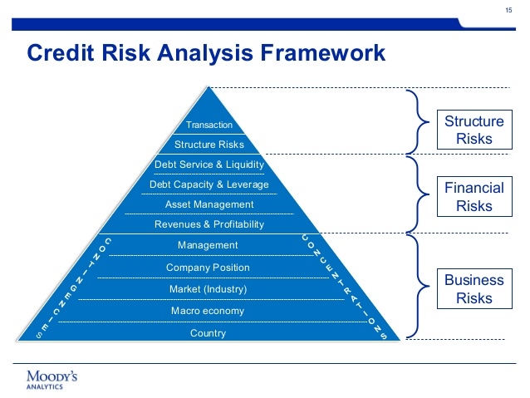

Below is the complete code that helps to forecast the Interest income of XYZ Bank for 9 Quarters
setwd("C:/Users/LOCALUSER/Desktop/material/stat/project/PIIN Models")
### Packages that need to be installed for Time series forecasting
library(forecast)
install.packages("fpp")
library(fpp)
#### Import the data to R environment
IIN<-read_excel("C:/Users/LOCALUSER/Desktop/material/stat/project/PIIN Models/PIN.xlsx" )
View(IIN)
### Analyse the basic statistics of imported data
summary(IIN)

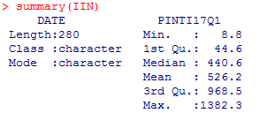

The data is ranging vast as the minimum, mean and maximum values of the time series (IIN) is varying large.
# Plot time series data
tsdisplay(IIN$PINTI17Q1)
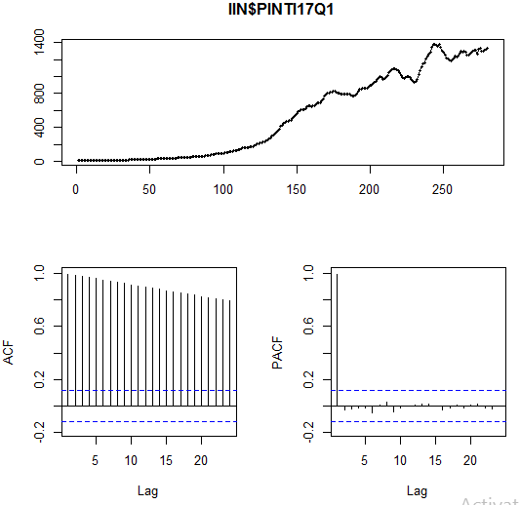

The 1st chart says that the series is ranging from almost 8 million dollars to 1400 million dollars.

## Applying box cox transformation
lambda = BoxCox.lambda(IIN$PINTI17Q1)
tsdata2 = BoxCox(IIN$PINTI17Q1, lambda=lambda)
tsdisplay(tsdata2)

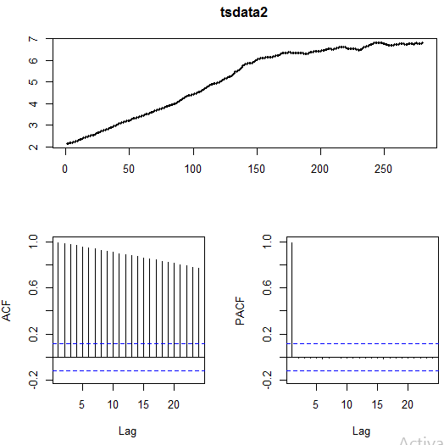

The Box cox transformation that has been applied is not helping the time series to convert into stationary. This can be interpreted by looking the continuous growth in the first chart.

#### Checking seasonal and Month plots
seasonplot(IIN$PINTI17Q1)

As Interest Income data do not depend on season, so we can’t execute seasonal plot
monthplot(IIN$PINTI17Q1)
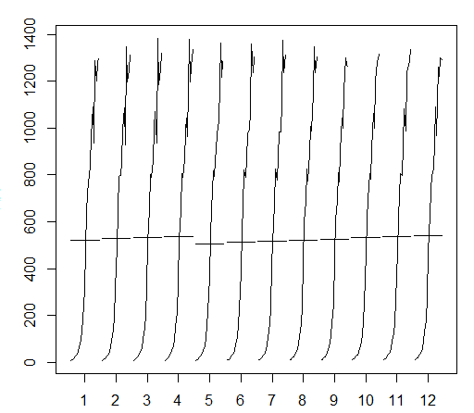
The below month plot also reavels the same as above statement. If the series expose to some seasonality the Interest Income series of each month would be different.

library("TTR")

###install.packages("forecast")
library(forecast)
trend_IIN= ma(IIN2[,2], order = 4, centre = T)
plot(as.ts(trend_IIN))
lines(trend_IIN)
plot(as.ts(trend_IIN))

write.csv(trend_IIN, "trend_IIN.csv")

trend_IIN2<-as.data.frame(trend_IIN)
trend_IIN3<-trend_IIN2[3:278,]
IIN_f<-IIN2[3:278,]
View(trend_IIN2)
View(IIN_f)
detrend_IINA = IIN_f[,2] - trend_IIN3
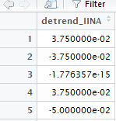

Above partial output explains about the series that has been generated after detrending the original Interest Income Series.

plot(as.ts(detrend_IINA))

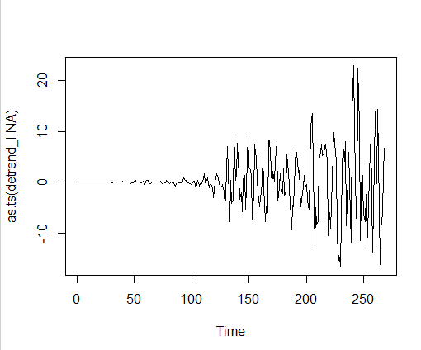

library(tseries)
adf = adf.test(detrend_IINA)
kpss = kpss.test(detrend_IINA)
adf
kpss

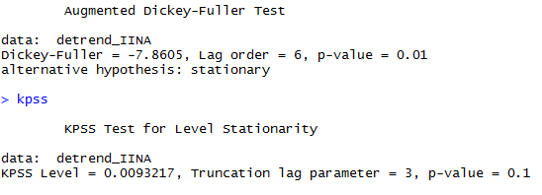

Adf test reject null hypothesis and KPSS test accepts null hypothesis. This explains that the seires is stationary.
### Creating acf and Pacf plots to check seasonal effect in any and to check AR term (p) and MA term (q).

acf(detrend_IINA, lag.max = 20)
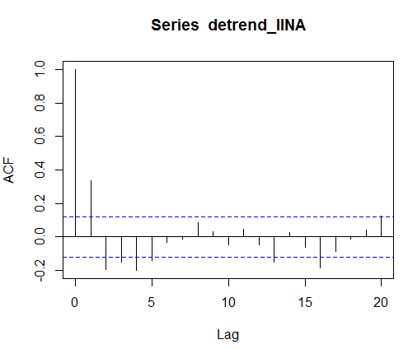
ACF Plot says that MA term or q is equals to 2.
pacf(detrend_IINA, lag.max = 20)

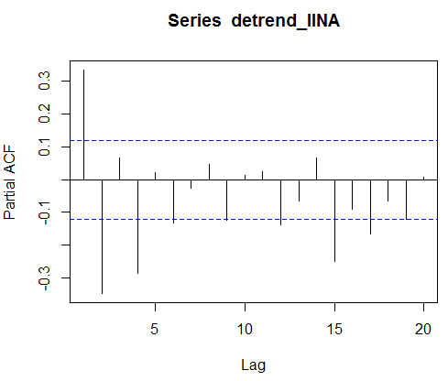
PACF Plot says that AR term or p is equals to 0.

#Automatic Selection Algorithm – Fast
auto.arima(detrend_IINA, trace= TRUE, ic ="aic")
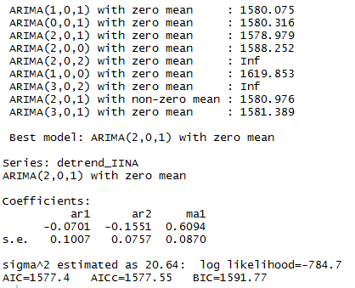
Auto.arima is giving that arima(0,0,0) with mean is appropriate model i.e, AR(p)=2 , MA(q)=1, d=0
Based on the Least AIC value criteria, it can be concluded that ARIMA(2,0,1) is our final model.
#### Final model fit
finalmodel = arima(detrend_IINA, order = c(2, 0, 1))
### Results of the final model
summary(finalmodel)

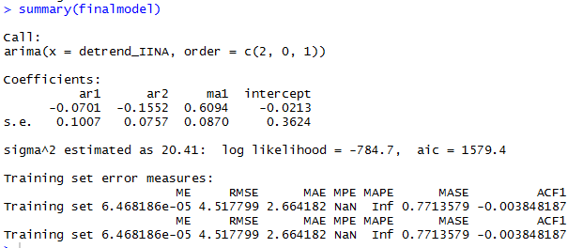
#### Residual analysis
res<-residuals(finalmodel)
res_final<-as.numeric(res)

#### Autocorrelation check
durbinWatsonTest(res_final)

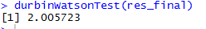

As the value in in the range of 1.7 to 2.3, the residuals are not exhibiting autocorrelation issue and we can stop the modeling.
### final prediction
predict(finalmodel, n.ahead = 9)
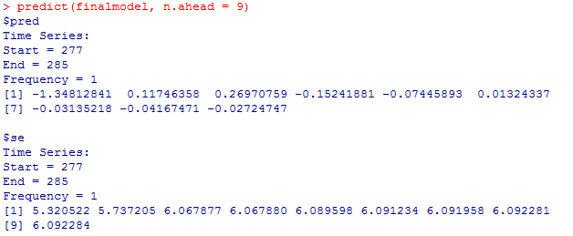
Above are the forecast values of the detrended time series.
Below is the code to test the model.

############Testing

trend_IIN4<-trend_IIN2[3:270,]
IIN_ft<-IIN2[3:270,]
detrend_IINA = IIN_ft[,2] - trend_IIN4

finalmodel1 = arima(detrend_IINA, order = c(2, 0, 1))
### Results of the final model
summary(finalmodel1)
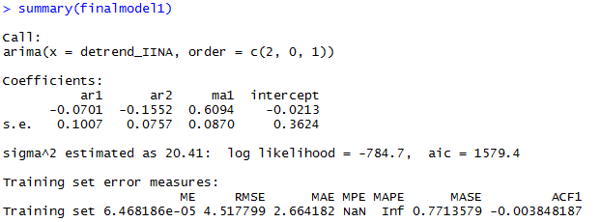
### final prediction
predict(finalmodel1, n.ahead = 9)
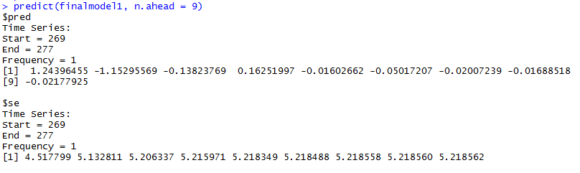

Above are detrended forecasts for testing period. i.e., for below quarters.
2014:Q2
2014:Q3
2014:Q4
2015:Q1
2015:Q2
2015:Q3
2015:Q4
2016:Q1
2016:Q2
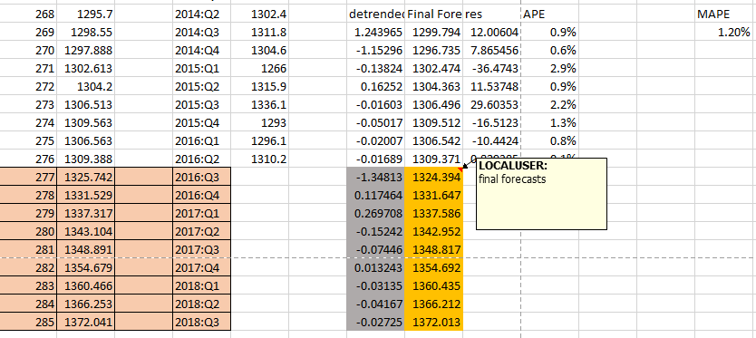
The Orange highlighted values are the forecast values of Interest Income. Refer the excel file for further clarifications.
Summary of Analysis
As per final results the forecasted Interest income of arima(2,0,1) is reasonable in nature and can be used further to calculate revenues of the bank for 9 quarters.
The Mean Absolute Percentage error is 1.20% which really small and good to proceed further with these forecasts.
Recommendation
A well-managed financial sector should have good risk management and crisis management system. We can use the statistical methods such as time series regression, VAR models are useful in risk analysis of bank data.
To forecast of Interest Income is a challenging task because, the real world data does not contain all the information required for analysis. Some part of data can be confidential and cannot be shared publically. The limitations about the data and other factors make the prediction a challenging task. The financial sector should analyze two main factors about revenue forecast. First one is Interest income, and other is non-interest income.
Since the credit risks are associated with the customer’s account, analyzing the account for balance gives a first hint towards the risk analysis process. But, in this case we don’t have information of the customers as the data is secured in nature. So, only banks interest income has been considered.
Conclusion:
Figure 1.1: Risk management framework


Source: Anderson and Abousleiman, 2011.
The analysis of XYZ banks data helps in predicting Income interest that can be effected with credit risk. While analyzing credit risk factors, it is essential to consider all the factors associated with the account such as account type, account balance trends, job type, number of members in the family, income other assets associated with the clients.
As the data related to customers is unavailable due to security concerns, bank level data has been taken and best arima model has been fitted. Thus arima(2,0,1) is the model used to forecast the Interest income for next 9 Quarters.
As the Interest Income data is historical data which has long time frame, the MAPE for development data set may not be validated.
The MAPE for Testing data is 1.2% which is reasonable in nature to comment that the model is good model.

References
http://www.bizjournals.com/kansascity/news/2014/06/23/community-banks-weak-net-interest-income.html

http://www.investopedia.com/terms/n/net-interest-income.asp

APPENDIX
Table A: DATASET: 2 Variables
Date | Year and Quarter
IIN | Interest Income
Table B. Exploratory Analysis

